Name: Yohannes Ayele

Assignment: Assignment 5_2

Date: 6/16/24

**Front-end Style Guide for BioSite**

**Selected Color Palette**

* **Primary Color**: #3498db (Blue)
* **Secondary Color**: #2ecc71 (Green)
* **Accent Color**: #e74c3c (Red)
* **Background Color**: #ecf0f1 (Light Gray)
* **Text Color**: #2c3e50 (Dark Gray)

**Typography**

* **Header Font**: Arial, sans-serif
* **Body Font**: Georgia, serif
* **Font Sizes**:
  + H1: 2em
  + H2: 1.5em
  + H3: 1.2em
  + Body: 1em

**Wireframes**

**Landing Page**

* Header with site title and navigation bar
* Main section with a large portrait of the subject
* Three sections for goals, personal accomplishments, and embellishments, each with an image and short description
* Footer with copyright information

**About Page**

* Header with site title and navigation bar
* Main section with a portrait of the subject
* 250-word biography
* Footer with a link to the hobbies page

**Hobbies Page**

* Header with site title and navigation bar
* Main section divided into three sections for different hobbies, each with an image and short description
* Footer with a link to the landing page

**Sketches**

* Include rough sketches of the Landing, About, and Hobbies pages. Use pencil and paper or digital tools like Sketch or Adobe XD.

**Interview Questions and Responses**

1. **What is your full name?**
   * Zele Mariam
2. **Where and when were you born?**
   * I was born in Addis Ababa, Ethiopia on July 15, 1980.
3. **What are your hobbies?**
   * Rock climbing, photography, and cooking.
4. **What do you do for a living?**
   * I am a software engineer.
5. **What are your personal goals?**
   * To run a marathon, learn a new language, and write a book.
6. **What are your proudest accomplishments?**
   * Completing my first skydiving jump, winning a photography contest, and creating a successful app.
7. **Who has been the most influential person in your life?**
   * My grandfather, who taught me the importance of hard work and perseverance.
8. **What is your favorite book or movie?**
   * My favorite book is "To Kill a Mockingbird" and my favorite movie is "The Shawshank Redemption."
9. **What is one thing you cannot live without?**
   * My camera.
10. **What are your future aspirations?**
    * To travel the world and experience different cultures.

**Short Bio of the Subject (250 words)**

Zele Marian born on July 15, 1980, in Addis Ababa, Ethiopia, has always been driven by a love for technology and adventure. As a software engineer, he has created several successful applications that have made notable contributions to the tech industry. Outside of work, Zeleis passionate about rock climbing, a hobby that brings him immense joy and a profound sense of freedom. He vividly remembers his first climb as one of the most thrilling experiences of his life.

Another of Zele's passions is photography. He loves capturing moments and transforming them into lasting memories. His skill in photography earned him recognition when he won a prestigious contest, a moment he cherishes as one of his proudest achievements. Additionally, Zele finds cooking to be a therapeutic and creative outlet.

Zele has set several personal goals for himself, including running a marathon, learning a new language, and writing a book. His grandfather has been a significant influence in his life, teaching him the values of hard work and perseverance. John's favorite book is "To Kill a Mockingbird," and his favorite movie is "The Shawshank Redemption."

With aspirations to travel the world and immerse himself in different cultures, Zele believes that travel can broaden his perspective and enrich both his personal and professional life. Armed with his camera, he is eager to explore new horizons and document his adventures.

**Images and Descriptions**

1. **Portrait of the Subject**

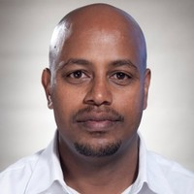

* + Portrait Image
  + This image will be placed on the About page above the biography.

1. **Images Related to Hobbies**

**Rock climbing**: Image 1

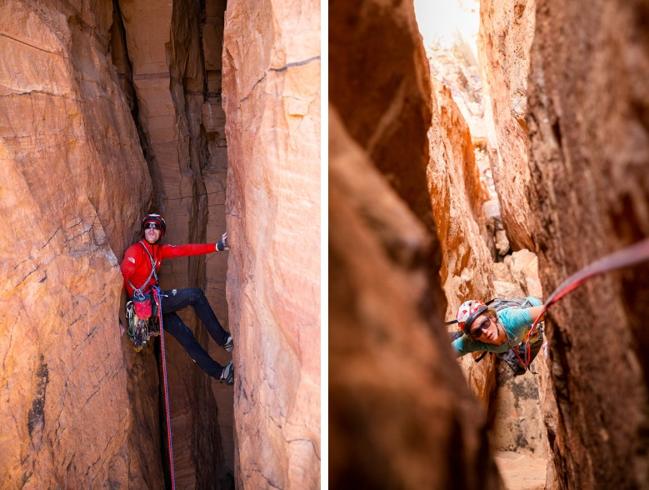

* + - Description: Zele during his first rock climbing.

1. **Photography**: image 2

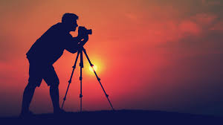

* + - Description: A photograph taken by Zele that won a contest.

1. **Cooking**: image3

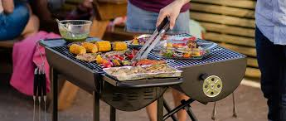

* + - Description: Zele preparing a gourmet meal.

**Images Related to Goals and Accomplishments**

1. **Marathon**: Image 4

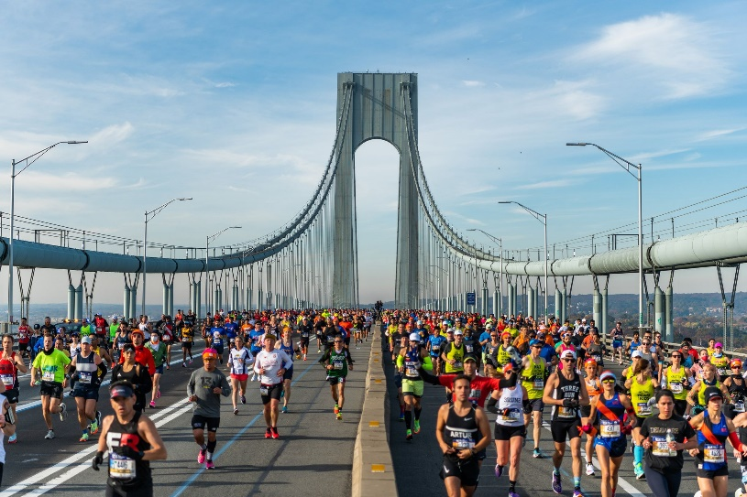

* + - Description: Zelet raining for his first marathon.

1. **Language Learning**: Image 5



* + - Description: Zele studying a new language.

1. **App Development**: Image 6



* + - Description: Zele presenting his successful app at a tech conference.